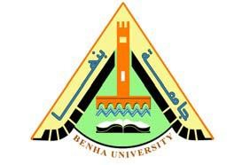

**Faculty of engineering - Shoubra**

**Benha University**

# Research Article / Research Project / Literature Review

in fulfillment of the requirements of

|  |  |
| --- | --- |
| **Department** | **Engineering Mathematics and Physics** |
| **Division** | **-------------------** |
| **Academic Year** | **2019-2020 Preparatory** |
| **Course name** | **Computer** |
| **Course code** | **ECE001** |

## Title: -

**Build a website on recent computer engineering topics**

By:

|  |  |  |  |
| --- | --- | --- | --- |
|  | Name | Edu mail | B.N |
| 1 | Abdelrahman amir hamed | Abdelrahman195489@feng.bu.edu.eg | 438 |

**Approved by:**

|  |  |
| --- | --- |
| Examiners committee | Signature |
| **Dr.Ahmed Bayoumi** |  |
| **Dr.Shady Elmashad** |  |
| **Dr. Abdelhamid Attaby** |  |

**Application brief**

An operating system is a powerful, and usually large, program that controls and manages the hardware and other software on a computer.

All computers and computer-like devices require operating systems, including your laptop, tablet, desktop, smart phone, smart watch, and router.

Laptops, tablets, and desktop computers all run operating systems that you've probably heard of. Some examples include versions of Microsoft Windows (like Windows 10, Windows 8, Windows 7, Windows Vista, and Windows XP), Apple's Mac OS (formerly OS X), Chrome OS, BlackBerry Tablet OS, and flavors of Linux, an open source operating system .

Your smart phone runs a mobile operating system, probably either Apple's iOS or Google's Android. Both are household names but you may not have realized that they are the operating systems running on those devices.

Servers, like those that host the websites you visit or serve the videos you watch, typically run specialized operating systems, designed and optimized to run the special software required to make them do what they do. Some examples include Windows Server, Linux, and FreeBSD.

**screenshots**

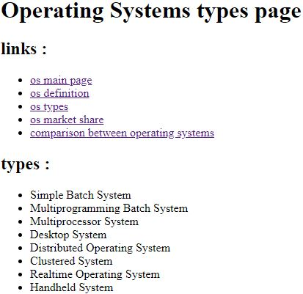

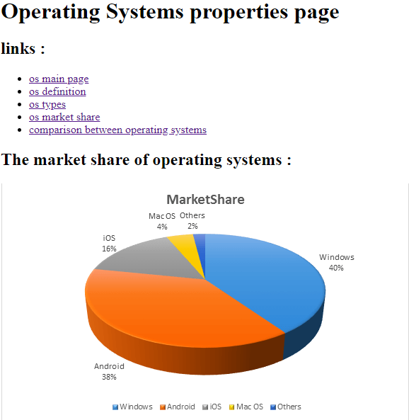

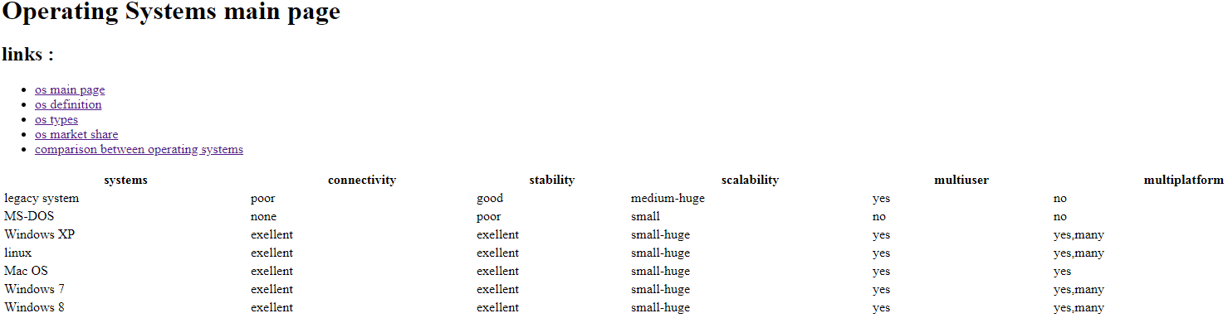

**source code**



